Case Study 75- Integrated Student Record Consistency Checker

1. Problem Statement
Develop a Python program to check the consistency and validity of student records. The program should accept student details such as name, roll number, age, and marks. It should validate the entered information, identify missing or invalid values, and check whether the marks are within the permitted range. Finally, it should display the student record along with its validation status and any errors found.

2. Objectives
- To accept student details from the user.
- To verify that required fields are not empty.
- To check that the roll number is valid and properly formatted.
- To validate the student's age.

3. Assumptions
- The student name and roll number are entered as text.
- The student name and roll number must not be empty.
- The student's age must be between 16 and 30 years.
- Marks must be between 0 and 100.

4. Algorithm
- Start the program.
- Input the student's name, roll number, age, and marks.
- Initialize an empty list to store validation errors.
- Check whether the student's name is empty.
- Check whether the roll number is empty.
- Check whether the age is between 16 and 30.
- Check whether the marks are between 0 and 100.
- Add an error message for every invalid field.
- If the error list is empty, display Record Valid.
- Otherwise, display Record Invalid and list all errors.
- Display the student record and validation results.
- Stop the program.
- Flowchart

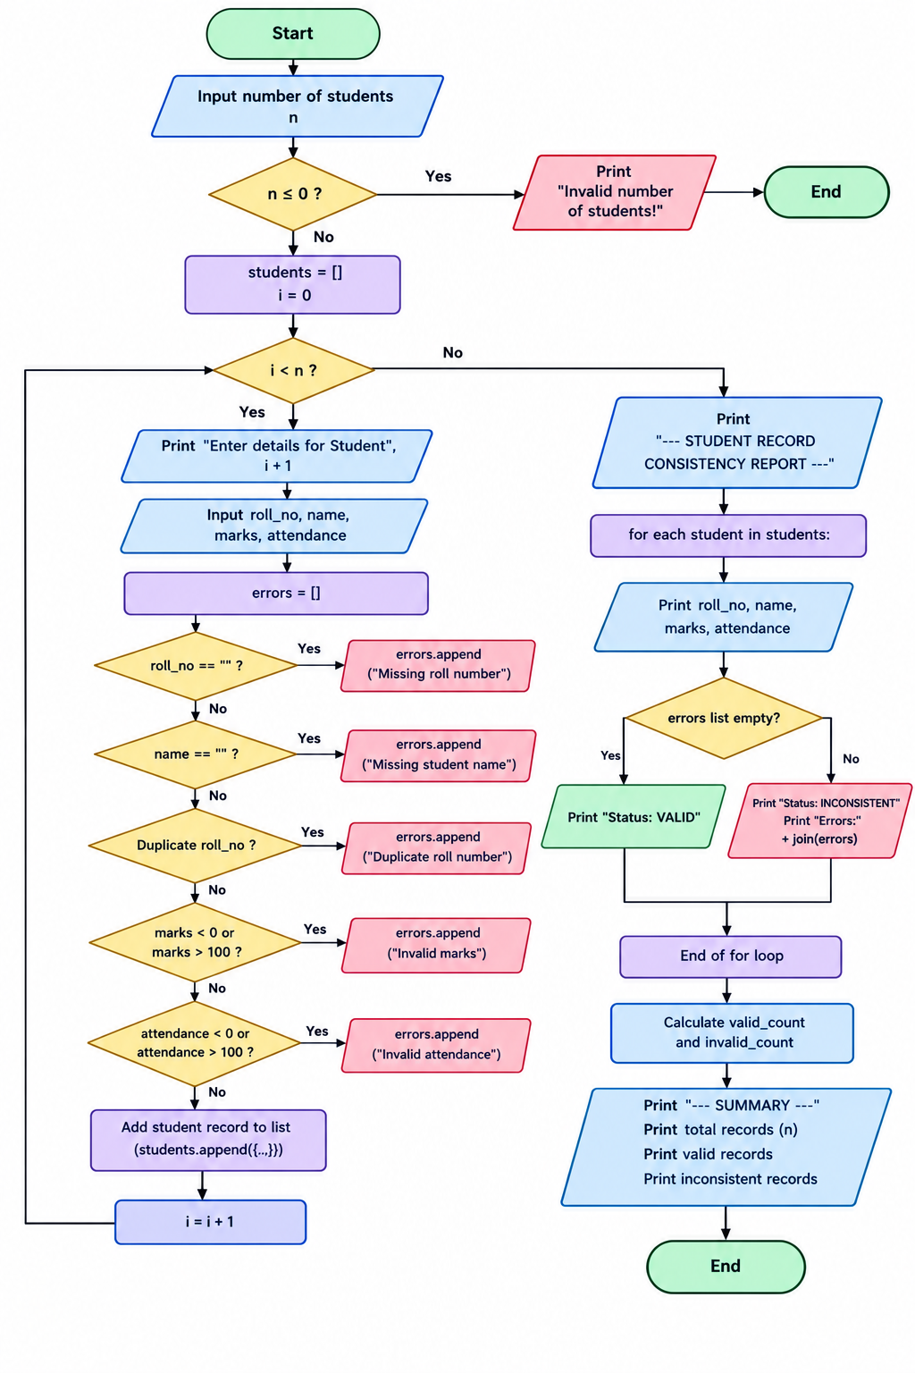

6. Pseudocode
BEGIN

INPUT student_name
INPUT roll_number
INPUT age
INPUT marks

errors = empty list

IF student_name is empty THEN
ADD "Student name is missing" TO errors
END IF

IF roll_number is empty THEN
ADD "Roll number is missing" TO errors
END IF

IF age < 16 OR age > 30 THEN
ADD "Invalid age" TO errors
END IF

IF marks < 0 OR marks > 100 THEN
ADD "Invalid marks" TO errors
END IF

IF errors is empty THEN
DISPLAY "Record Valid"
ELSE
DISPLAY "Record Invalid"
DISPLAY errors
END IF

DISPLAY student details

END

7. Test Cases
Test case | Name | Roll No. | Age | Marks | Expected result
1 | Damini | CSM101 | 18 | 85 | Valid
2 | Empty | CSM102 | 19 | 75 | Invalid name
3 | Ravi | Empty | 20 | 80 | Invalid roll number
4 | Priya | CSM104 | 15 | 90 | Invalid age
5 | Arun | CSM105 | 18 | 105 | Invalid marks
6 | Kumar | CSM106 | 32 | -5 | Invalid age and marks

8. Output

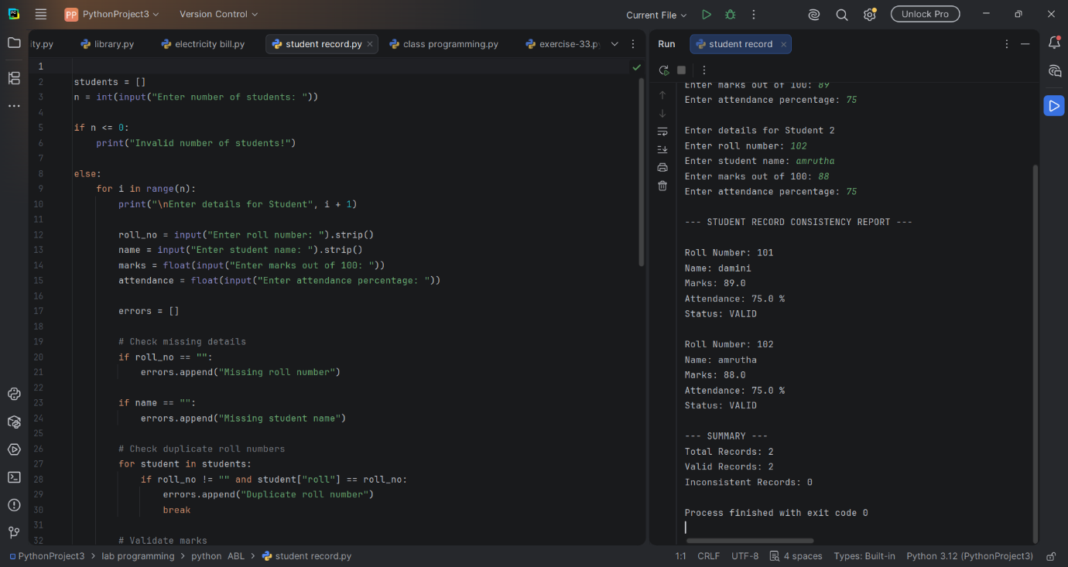

9. Conclusion
The Integrated Student Record Consistency Checker validates student information and identifies missing or incorrect data. It uses conditional statements and a list of errors to determine whether a record is valid or invalid. This program helps improve data accuracy, reduce manual errors, and maintain reliable student records.

